**HOME AUTOMATION USING THINKER CAD**



BY

SHRIKANTH M HOSALLI

USN:1CR21EC205

“Home automation” refers to **the automatic and electronic control of household features, activity, and appliances**.

**CIRCUIT DIAGRAM**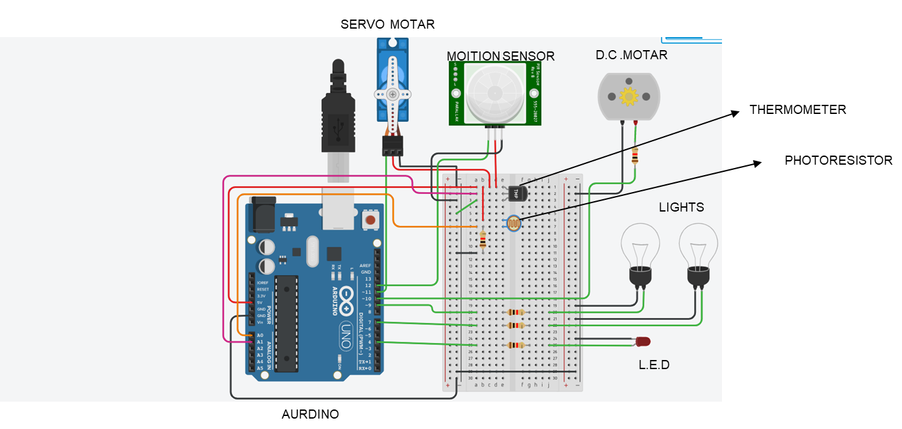

**AURDINO CODE**

#include <Servo.h>

const int ldrPin = A0;

const int tmpPin = A1;

const int motor = 10;

const int light = 9;

const int light2 = 7;

const int led = 4;

int rip = 0;

int servo = 0;

Servo servo_11;

int i;

void setup() {

pinMode(ldrPin, INPUT);

pinMode(tmpPin, INPUT);

pinMode(motor, OUTPUT);

pinMode(light, OUTPUT);

pinMode(light2, OUTPUT);

pinMode(led, OUTPUT);

Serial.begin(9600);

pinMode(12, INPUT);

pinMode(11, INPUT);

servo_11.attach(11, 500, 2500);

}

if (rip == 1) {

servo_11.write(180);

}

else {

servo_11.write(0);

}

if (-40 + 0.488155 * (tmpStatus - 20) > 28 ) {

analogWrite(motor,255);

} else {

analogWrite(motor,0);

}

else if(ldrStatus> 409 && ldrStatus<=544 ){

analogWrite(light,255);

analogWrite(light2,0);

analogWrite(led,0);

}

else if(ldrStatus> 274 && ldrStatus<=409){

analogWrite(light,255);

analogWrite(light2,0);

analogWrite(led,0);

}

else if(ldrStatus>=139 && ldrStatus<=274 ){

analogWrite(light,255);

analogWrite(light2,0);

analogWrite(led,0);

}